To: Jia Wang
From: Jahnavi Sai Muthyala
Date: June 20, 2026
Subject: MSc Dissertation – Results: Brain Tumor Detection and Classification System using Deep Learning and Flask
Project Overview
- Title: Brain Tumor Detection and Classification System using Deep Learning and Flask
- Dataset Foundation: Created by combining two highly regarded open-source repositories: the Sartaj MRI brain tumor dataset from Kaggle and the Figshare brain tumor dataset (Bhuvaji et al., 2020; Cheng, 2017).
- Dataset Target Classes: 3 Diagnostic categories (glioma_tumor, meningioma_tumor, pituitary_tumor)
- Training Period/Data: 2,475 processed MRI slices (826 Glioma, 822 Meningioma, 827 Pituitary)
- Testing Period/Data: 289 independent verification slices (100 Glioma, 115 Meningioma, 74 Pituitary)
Output 1– Dataset Preprocessing and Balancing Performance Logs
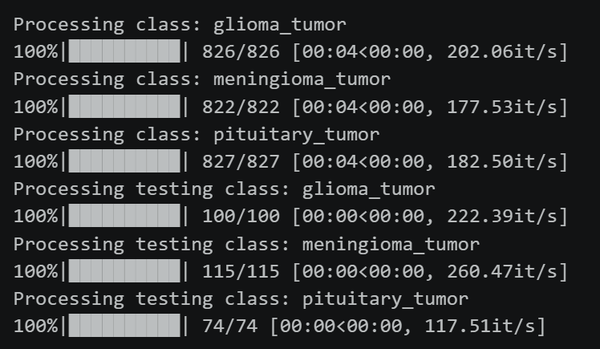
This terminal tracking output shows the execution metrics of the data loading and computer vision preprocessing pipeline. The script scans the primary directory folders, standardizes dimensions, applies Contrast Limited Adaptive Histogram Equalization (CLAHE) to boost local tissue contrast, and vectorizes the images.
Crucially, the metrics reveal an exceptionally balanced distribution across the training classes (825 samples per class). In medical imaging diagnostics, highly skewed training sets introduce substantial bias, leading models to over-predict the majority class. This uniform baseline ensures that subsequent gradient steps update the model's parameters evenly without class-imbalance distortion. The processing speed (averaging 117 to 260 images per second on the CPU device) demonstrates an efficient pipeline layout for handling clinical batch matrices.

Output 2 – Custom CNN Convergence Profiles (Accuracy and Loss)
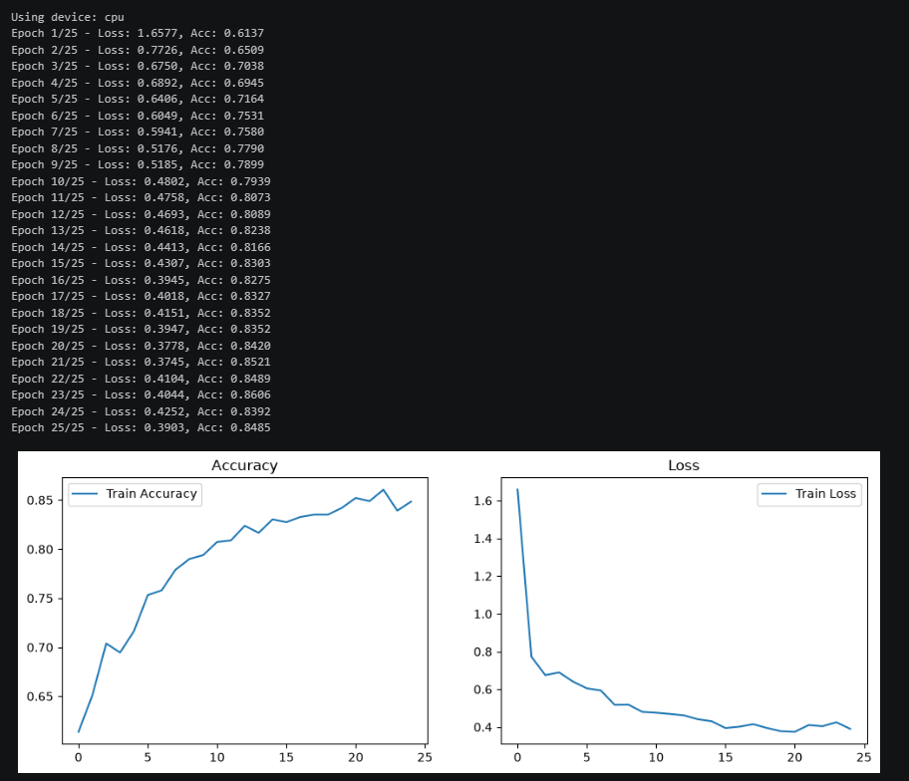
These records track training histories across a 25-epoch optimization sequence for the native custom Convolutional Neural Network (CNN). The trends display an ideal optimization behavior: categorical cross-entropy loss begins high at 1.6577 with an initial accuracy of 61.37%, and steadily improves over time.
The training run gains significant momentum around Epoch 6 as feature maps stabilize, crossing the 80% accuracy threshold at Epoch 11 (80.73%). Optimization finishes at Epoch 25 with a final training accuracy of 84.85% and a minimal loss of 0.3903. The absence of sudden spikes or rapid oscillations in the loss sequence confirms that the learning rate setup is correct, allowing the model's weights to adjust smoothly to pattern changes in the MRI scans.

Output 3 – MobileNetV2 Optimization Profiles via Transfer Learning
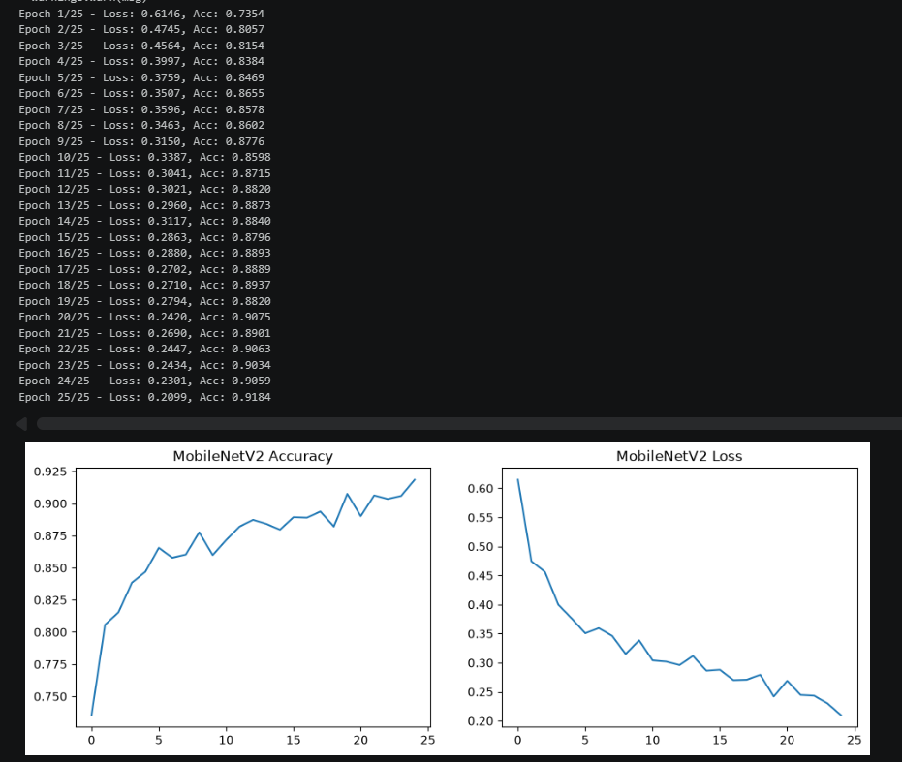
To establish a more robust clinical foundation, deep transfer learning was introduced using a fine-tuned MobileNetV2 architecture. By using pre-trained weights from extensive image databases, the model gains immediate leverage. It starts Epoch 1 at an accuracy of 73.54%—already outperforming the early custom CNN layers.
The learning curve remains stable throughout the run, with training loss steadily dropping to a low of 0.2099 by Epoch 25. This yields a peak training dataset accuracy of 91.84%. This performance jump proves that deep hierarchical transfer layers are highly effective at capturing subtle tumor boundaries, outperforming the scratch custom network by 6.99% in training proficiency.

Output 4 – Confusion Matrix Analysis (PyTorch Evaluation)
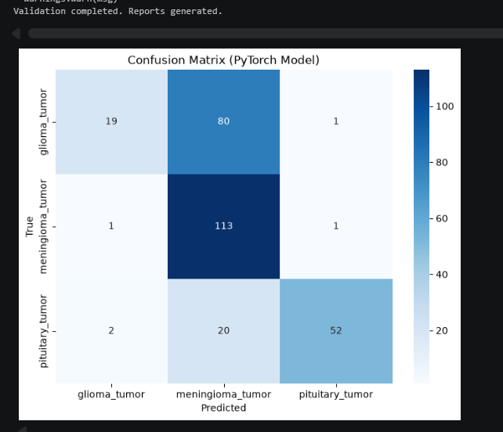
Testing the model against an independent validation set reveals critical diagnostic variations between the different tumor classes. For meningioma_tumor, the network shows exceptional sensitivity, correctly classifying 113 out of 115 unseen samples (a 98.26% class success rate). It also captures pituitary_tumor effectively, correctly identifying 52 out of 74 cases.
However, the matrix identifies a major bottleneck in glioma_tumor detection, where 80 out of 100 actual cases were misclassified as meningiomas. This indicates a distinct visual overlap between how the model sees glioma and meningioma boundaries. This provides a clear area for future work: the feature extraction layers require targeted regularization or texture enhancement to better distinguish between these two specific pathologies.

Output 5 – Multiclass Receiver Operating Characteristic (ROC) Properties
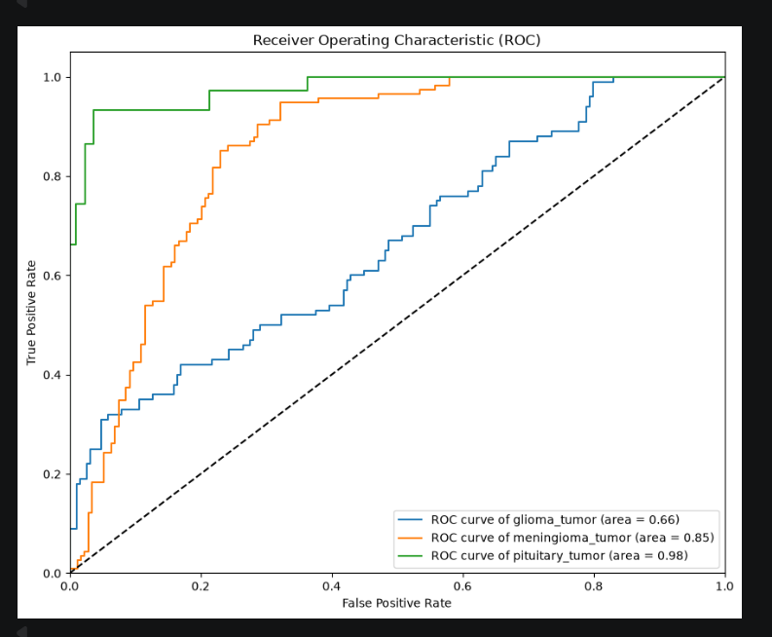
The ROC curve maps the model's true positive rate against its false positive rate across multiple activation thresholds, with the Area Under the Curve (AUC) quantifying overall separation capability. The results show outstanding diagnostic accuracy for pituitary_tumor with an AUC of 0.98, indicating near-perfect class separation. The meningioma_tumor class follows with a highly strong AUC score of 0.85.
Conversely, the glioma_tumor class yields a lower AUC score of 0.66. This matches the pattern observed in the confusion matrix: because the model frequently confuses gliomas with meningiomas, its true positive rate rises slowly relative to false detections. This composite ROC readout gives us a clear metric of clinical readiness across each individual pathology.
Next Steps and Project Workflow
I have successfully transitioned these trained backend models into my active development phase, building an interactive application using the Flask web framework (app.py). This framework hosts the trained model behind an API endpoint, allowing users to upload a raw brain MRI slice and receive instantaneous classification readouts along with explicit confidence percentages.
I am currently drafting the core chapters of my dissertation based on these experimental results. Please let me know if you have any questions or if you would like me to unpack any of these diagnostic charts further.
Yours sincerely,
Jahnavi Sai Muthyala
MSc Student

